***Online report:*** *a visually engaging summary of key findings (sits above the current report online).* *The aim is to encourage researchers to drill down into the details, formulate their own research questions and make use of the public available survey data.*

* Introduction to the People and Nature survey
  + Intended audience
  + Where to find the data and more analysis
* Feelings about nature
  + Very high percentages of people value and enjoy nature, but somewhat lower percentage feel part of nature.
* green space visits and Covid-19
  + Annual average prop visited in last 14 days
    - Perhaps hard to feel part of nature, if not visiting …
  + Overall trend for visits (and uncertainty around this).
  + Annual trend likely driven by Covid-19 restrictions and concerns.
  + But, people feeling and being engaging more with the environment during the pandemic too.
  + Other notable findings:
    - Differences in number of visits across the ages groups
    - Many more people not visiting, than visiting everyday
* *(But inequality)* perceptions of green space
  + People with higher household incomes more likely to perceive improvement in quality over last 5 years
* Clearly many people value nature and enjoy visiting natural spaces. So, what are people doing to protect nature?
  + Large proportions of people are not frequently engaging in high environmental impact activities (fly and commuting by car). Eating meat remains a high impact activity that many people engage in regularly.

**Disclaimer:** This is a personal project using publicly available data. Natural England were not involved in the project at any stage. I worked on this project prior to starting employment with Natural England. Any, and all, mistakes in the analysis, interpretation or presentation of the data were my own.

**The project in one sentence:** Communicating, in a visually engaging but scientifically rigorous way, the key findings of the [People and Nature Survey](https://www.gov.uk/government/collections/people-and-nature-survey-for-england) (Apr. 2020 – Mar. 2021).

**The project in more detail:**

|  |  |  |  |  |
| --- | --- | --- | --- | --- |
| **Format** |  | **Audience** |  | **Objectives** |
|  |  |  |  |  |
| A data story for inclusion in a printed report and/or a webpage. |  | Academic and policy researchers with an interest in green space and people’s relationship with it.  *Likely to be viewing online on a desktop (rather than mobile).* |  | * Inform academic and policy researchers about key findings of the survey. * Encourage researchers to look at more detailed reports on survey findings. * Encourage researchers to formulate their own research questions and make use of publicly available dataset |

**A bit more about the format:** This piece takes the form of a data story incorporating text and visuals. The text around the visuals is (I think) the minimal needed to tell the story and connect the visuals. The text offers a skeleton which could be iteratively develop in collaboration with people who hold deep expertise in the subject area.

**The process:** I reviewed the published summary of the main findings of the [People and Nature Survey](https://www.gov.uk/government/statistics/the-people-and-nature-survey-for-england-data-and-publications-from-adults-survey-year-1-april-2020-march-2021-official-statistics/the-people-and-nature-survey-for-england-data-and-publications-from-adults-survey-year-1-april-2020-march-2021-official-statistics-main-finding) (Apr. 2020 – Mar. 2021). This is an online report which presents a wide range of fairly detailed statistical results. Some of these results were presented with accompanying visualisations. I took these visualised results to be the headlines, as the team analysing the survey had gone to additional effort to produce visualisations. Focusing on these headline findings I analysed the raw survey data (which was publicly available). Then through multiple iterations, I developed and refined the text and visualisations that make up the data story presented below.

**Tools used:** R for data cleaning *(Tidyverse)*, statistical analysisand creating data visualisations *(ggplot2).* Microsoft Excel for producing tables. Affinity Designer, Affinity Publisher and Inkscape for creating and editing data visualisations.

**Connecting with nature during the early ‘days’ of the Covid-19 pandemic**

*A data story (for researchers)*

Dr. Christopher Martin (20th January 2022)

Below I offer a data-driven story about how people connected with and thought about nature early on in the Covid-19 pandemic (specifically during the period April 2020 to March 2021). This story is built on data from [People and Nature Survey](https://www.gov.uk/government/statistics/the-people-and-nature-survey-for-england-data-and-publications-from-adults-survey-year-1-april-2020-march-2021-official-statistics/the-people-and-nature-survey-for-england-data-and-publications-from-adults-survey-year-1-april-2020-march-2021-official-statistics-main-finding), a survey which is run each month by Natural England[1]. More details about the survey methodology and results, and the survey data itself can be found [here](https://www.gov.uk/government/collections/people-and-nature-survey-for-england). I hope that the results presented here will encourage researchers to explore the survey data, come up with new research questions and conduct new studies.

Below I am going to explain …

Alongside the survey results presented below, I will highlight a couple of area where I think there are great opportunities for further research. All the statistical details, including sample sizes etc., can be found in this l0nger and more comprehensive [report](https://www.gov.uk/government/statistics/the-people-and-nature-survey-for-england-data-and-publications-from-adults-survey-year-1-april-2020-march-2021-official-statistics/the-people-and-nature-survey-for-england-data-and-publications-from-adults-survey-year-1-april-2020-march-2021-official-statistics-main-finding) written by Natural England.

Many of survey participants agreed (82 or 83%) with a series of statements about nature having value to them (shown in blue in the figure below). However, less participants agreed (58%) with a statement about how connected with nature they feel (“I feel part of nature”, shown in green below). So, there is some evidence of a gap between how many people value nature and how many feel actually connected to nature.

*This visualisation was inspired by a* [*figure*](https://assets.publishing.service.gov.uk/government/uploads/system/uploads/image_data/file/132054/fig5.png) *produced by Natural England.*

***Opportunities for further research:*** The gap identified above is something that researchers could explored further through analysis of the survey data and new qualitative research.

We have seen that only 58% of survey participants could agree with the statement “I feel part of nature”. That leaves a lot of survey participants (42%) who either disagree with or were not sure about the statement. I wondered if perhaps it is difficult to feel part of nature without spending some time in natural and green spaces. So, next I turn to the survey results focused on how often people visits to green spaces.

Averaged over the year (from April 2020 to March 2021), the survey results show that typically 29% will not have visited a green space in the last 14 days. While in contrast only 7% will have visited a green space 14 times or more in the last 14 days (something we might think about as approximating visiting every day).

Focussing in on the question of whether survey participants have made a visit to green space in the last 14 days, it is interesting to see how this varies from month to month. So, the potential impacts of Covid-19 restrictions, and potential seasonal affects, come into view. In the figure below, an increase in the percentage of people who had visited in the last 14 days can between April and August 2020. This of course coincides with the relaxation of Covid-19 restrictions after the first lockdown. The percentages do not sum to 100% as, for simplicity, “don’t know” and “prefer not to say” survey responses are not shown.

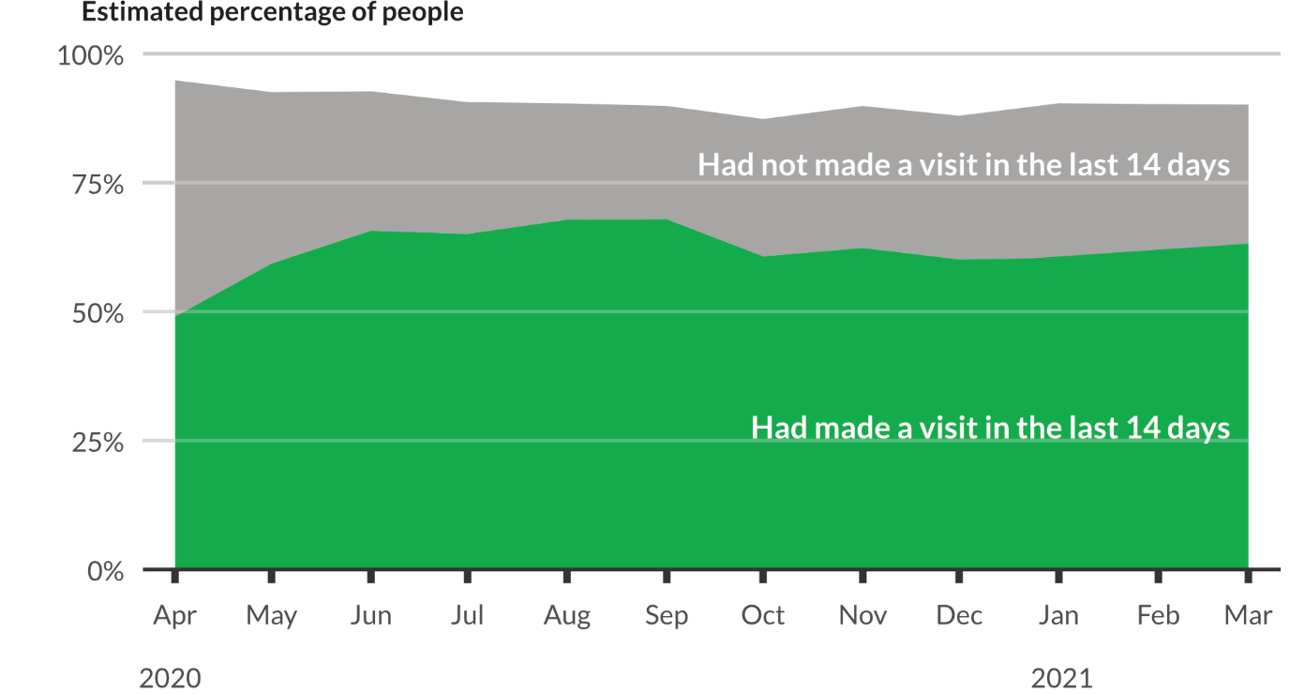

*This visualisation was inspired by a* [*figure*](https://assets.publishing.service.gov.uk/government/uploads/system/uploads/image_data/file/132050/fig1.png) *produced by Natural England.*

The figure below focuses down on just those people who had visited in the last 14 days. This emphasises the increase in people visiting over the spring and summer, before falling back over the Autumn and Winter. The falling back perhaps reflects a combination of seasonal affects and increasing Covid-19 restrictions. Focusing down, also provides the opportunity to acknowledge and show the uncertainty around population estimates based on the survey results (95% confidence intervals are shown in light green).

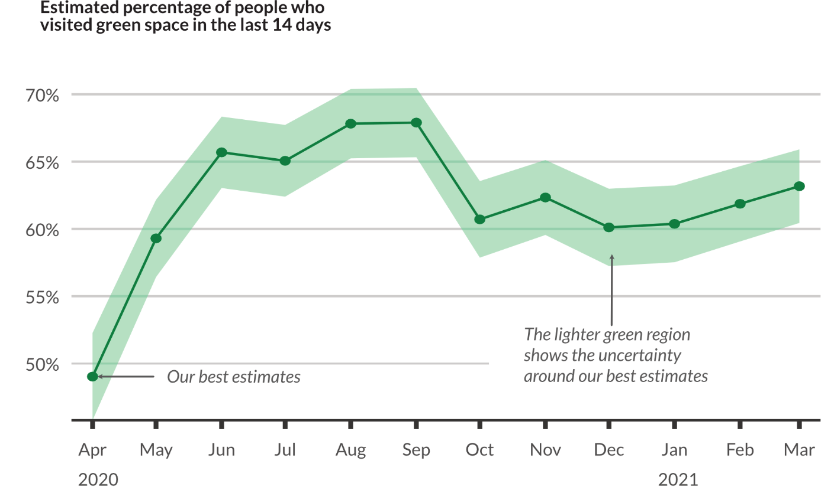

*This visualisation was inspired by a* [*figure*](https://assets.publishing.service.gov.uk/government/uploads/system/uploads/image_data/file/132050/fig1.png) *produced by Natural England.*

If more details of these results is of interest, then take a look at the table below. Otherwise, just skip on to the next part of the data-story.

*This table was inspired by a* [*figure*](https://assets.publishing.service.gov.uk/government/uploads/system/uploads/image_data/file/132050/fig1.png) *produced by Natural England.*

Since the beginning of the pandemic the People and Nature Survey has been asking a series of questions about Covid-19. Some of this data can help us to understand the trends described above. In particular, the survey asked people about their reasons for not spending time outdoors over the last 14 days. In the figure below, we can see the role played by Covid-19 restrictions and concerns over the year.

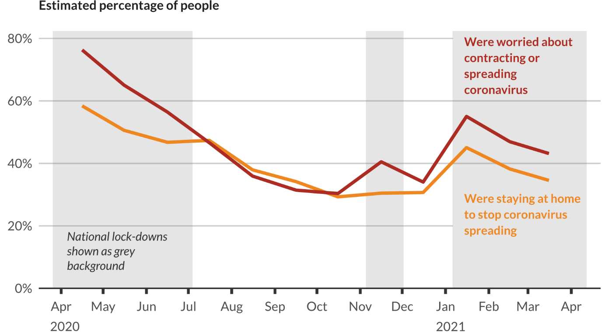

*This visualisation was inspired by a* [*figure*](https://assets.publishing.service.gov.uk/government/uploads/system/uploads/image_data/file/132052/fig3.png) *produced by Natural England.*

In the figure below, for three months, from April to June 2020, we see falling fear of Covid-19 correlated with more people visiting green space. After that, the relationship between the percentage of people citing fear of Covid-19 as a reason not to spend time outdoors, and the percentage of people visiting green spaces, is more complex.

So, the pandemic, and associated restrictions, have contributed to some people’s reluctance to spend time outdoors. In parallel considerable numbers of people have been engaging more with the environment during the pandemic too. The figure below shows these levels of increased engagement were sustained between April 2020 and March 2020.

*This visualisation was inspired by a* [*figure*](https://assets.publishing.service.gov.uk/government/uploads/system/uploads/image_data/file/132052/fig3.png) *produced by Natural England.*

Looking beyond the pandemic, there are some interesting relationship between age and frequency of visiting green spaces. The figure below shows that the percentage of people who have not visited green space in the last 14 days increases with age.

*This visualisation was inspired by a* [*figure*](https://assets.publishing.service.gov.uk/government/uploads/system/uploads/image_data/file/132051/fig2.png) *produced by Natural England.*

However, older age groups (specifically those 40 or older) are more likely to visit green spaces very frequently.

*This visualisation was inspired by a* [*figure*](https://assets.publishing.service.gov.uk/government/uploads/system/uploads/image_data/file/132051/fig2.png) *produced by Natural England.*

Data from the People and Nature survey can also understand the relationship between inequality and green space. Survey respondents were asked if they perceived the quality of their local green spaces had improved or reduced over the last five years. Respondents with higher household incomes were more likely to perceive improvements in quality. It is worth noting that across all income bands many respondents provided a neutral response (indicating no perceived change in quality).

*This visualisation was inspired by a* [*figure*](https://assets.publishing.service.gov.uk/government/uploads/system/uploads/image_data/file/132053/fig4.png) *produced by Natural England.*

The results above show that many people value nature and enjoy visiting natural spaces. The data collected in the People and Nature survey can also addresses the question of what are people doing to protect nature. In the figure below we can see large proportions of people are not frequently engaging in high environmental impact activities (fly and commuting by car). However, eating meat remains a high impact activity that many people engage in regularly.

1. Natural England are a public sector organisation responsible for:

   * protecting and enhancing the natural environment;

   and, promoting people’s connection with the natural environment.